Employee Directory with Department and Skill Sets
A Course End Project Report Submitted in the Partial Fulfillment of the Requirements for the Award of the Degree of
Bachelor of Technology
in
Computer science and engineering (AI&ML)
Python Laboratory (A8508)

Submitted By
MANDAPALLI AJAYBABU | 24881A66F5
PATIL PANDU RANGA | 24881A66G6
POOJALA JAIVARDHAN | 24881A66G7

Under the Esteemed Guidance of
Ms. S Uma Maheswari
Assistant Professor

DEPARTMENT OF COMPUTER SCIENCE AND ENGINEERRING (AI&ML)
Vardhaman College of Engineering
(AUTONOMOUS)
Affiliated to JNTUH, Approved by AICTE, Accredited by NAAC, with A++ Grade, ISO 9001:2015 Certified
Kacharam, Shamshabad, Hyderabad – 501218, Telangana, India
2024- 25
DECLARATION

I hereby declare that the work described in this report entitled “Employee Directory with Department and Skill Sets” which is being submitted by us in partial fulfilment for the award of BACHELOR OF TECHNOLOGY in the Department of Computer Science & Engineering (AI&ML), Vardhaman College of Engineering to the Jawaharlal Nehru Technological University Hyderabad.

The work is original and has not been submitted for any Degree or Diploma of this or any other university.

MANDAPALLI AJAYBABU (24881A66F5)
PATIL PANDU RANGA (24881A66G6)
POOJALA JAIVARDHAN (24881A66G7)



Vardhaman College of Engineering
(AUTONOMOUS)
Affiliated to JNTUH, Approved by AICTE, Accredited by NAAC, with A++ Grade, ISO 9001:2015 Certified
Kacharam, Shamshabad, Hyderabad – 501218, Telangana, India
Department of Computer Science and Engineering (AI&ML)

CERTIFICATE

This is to certify that the Course End Project report work entitled “Employee Directory with Department and Skill Sets” carried out by Mr. MANDAPALLI AJAYBABU, Roll Number 24881A66F5, Mr. PATIL PANDU RANGA, Roll Number 24881A66G6, Mr. POOJALA JAIVARDHAN, Roll Number 24881A66G7 towards Course End Project and submitted to the Department of Computer Science and Engineering (AI&ML), in partial fulfillment of the requirements for the award of degree of Bachelor of Technology in Computer Science and Engineering (AI&ML) during the year 2024-25.

Name & Signature of the HOD

Dr. M. A. Jabbar
HOD, CSE(AI&ML)
Name & Signature of the Instructors

Ms. S. Uma Maheswari
Assistant Professor

ACKNOWLEDGEMENT

The satisfaction that accompanies the successful completion of the task would be put incomplete without the mention of the people who made it possible, whose constant guidance and encouragement crown all the efforts with success.
We wish to express my deep sense of gratitude to Ms. S Uma Maheswari, Assistant Professor for their able guidance and useful suggestions, which helped us in completing the
design part of potential project in time.
We are particularly thankful to Dr. M. A. Jabbar, Professor & Head, Department of Computer Science and Engineering (AI&ML) for his guidance, intense support and encouragement, which helped us to mould our project into a successful one.
We show gratitude to our honorable Principal Dr. J. V. R. Ravindra, for having provided all the facilities and support.
We avail this opportunity to express our deep sense of gratitude and heartful thanks to Dr. Teegala Vijender Reddy, Chairman and Sri Teegala Upender Reddy, Secretary of VCE, for providing congenial atmosphere to complete this project successfully.
We also thank all the staff members of the department of CSE(AI&ML) for their valuable support and generous advice. Finally, thanks to all our friends and family members for their continuous support and enthusiastic help.

ABSTRACT

The Employee Directory with Department and Skill Sets project is developed to offer a centralized platform for managing employee information effectively. This application allows users to search for employees based on their skill sets, departments, or view all employees through a categorized menu. It simplifies the process of accessing and organizing workforce data, especially in medium to large-scale organizations.
One of the key features of the system is the ability to add new employees dynamically, ensuring that the directory remains current and scalable. The search functionality enhances user experience by enabling quick retrieval of relevant employee profiles, which is particularly useful for HR teams and department heads during team formation or recruitment planning.
The project combines front-end and back-end technologies to create an intuitive interface supported by efficient data handling mechanisms. It aims to improve transparency, reduce manual record keeping, and foster better internal communication by making employee data readily accessible.
In essence, this project serves as a valuable tool for digital workforce management, offering both functionality and convenience through a structured and searchable employee directory.

ABBREVATIONS

Abbreviation | Expansion
ID | Identification Number
HR | Human Resources
SEO | Search Engine Optimization
ML | Machine Learning

Table of Contents
Chapter No. | Title | Page No.
 | Acknowledgements | IV
 | Abstract | V
 | Abbreviations | VI
Chapter 1 | Introduction | 1
 | 1.1 Scope | 1
 | 1.2 Objectives | 2
Chapter 2 | Problem Definition and System Methodology | 2-5
 | 2.1 Problem statement | 2
 | 2.2 Methodology | 2
 | 2.3 Code | 3-5
Chapter 3 | Software Requirements Specification and Hardware Requirements | 6-7
Chapter 4 | System Design Diagrams and Output | 8-9
Chapter 5 | Results and Discussions | 10
Chapter 6 | Conclusion | 11
 | References | 12

Chapter 1
Introduction

  - Scope
The Employee Directory with Department and Skill Sets project aims to create an efficient platform for managing employee data. It allows users to search employees by skill set and department, and provides the ability to add new employee records. The application will be user-friendly, scalable, and designed to streamline employee management for organizations of all sizes. It includes both front-end features for easy navigation and a back-end system for effective data storage and retrieval.
  - Objectives
• Provide a centralized platform for managing and accessing employee data.
• Enable users to search employees by department, skill set, and other attributes.
• Streamline identification of suitable employees for tasks, projects, or teams.
• Allow easy addition of new employee records to keep the directory updated.
• Improve organizational efficiency by reducing manual record-keeping time.
• Deliver an intuitive interface for quick navigation and data retrieval.
• Support scalability to handle growing employee numbers as the organization expands.
• Simplify administrative processes, enhance interdepartmental communication, and offer a flexible employee management solution.

Chapter – 2
Problem Definition and System Methodology

2.1 Problem statement
Manual employee data management is inefficient, error-prone, and hinders decision-making. Traditional methods struggle with updates, skill-based searches, and scaling. This project aims to create an automated, centralized employee directory for easy searching, updating, and retrieval of information, streamlining tasks, ensuring data accuracy, and enhancing communication as organizations grow.

2.2 Methodology
The development of the Employee Directory with Department and Skill Sets system follows a structured and systematic approach, combining both agile and waterfall methodologies for effective execution. The project is divided into multiple phases, starting with the planning and requirement analysis phase. In this phase, the needs of the organization are identified, including the essential features such as employee search by department and skill sets, the ability to add new employees, and the display of all employees in a structured menu.
The design phase involves creating wireframes and system architecture for both the front-end user interface and back-end database structure.
In the development phase, coding will be done for both the user interface and database integration. The system will be built incrementally, allowing for testing at each step. After development, the system will undergo quality testing to ensure that the features such as search, adding, and displaying employees are functioning as expected.
Finally, the deployment phase will involve the implementation of the system in the organization's environment, followed by user training and feedback collection to make any necessary adjustments.

2.3 Code
# Enhanced Employee Directory System with Display All Employees

# Initialize employee records with Indian names
employee_records = {
201: {'info': (201, 'Amit'), 'department': 'HR', 'skills': {'Communication', 'Recruitment'}},
202: {'info': (202, 'Priya'), 'department': 'Engineering', 'skills': {'Python', 'Machine Learning'}},
203: {'info': (203, 'Rahul'), 'department': 'Engineering', 'skills': {'Java', 'System Design'}},
204: {'info': (204, 'Neha'), 'department': 'Marketing', 'skills': {'SEO', 'Content Writing'}},
205: {'info': (205, 'Vikram'), 'department': 'Engineering', 'skills': {'Python', 'DevOps'}},
206: {'info': (206, 'Sneha'), 'department': 'Sales', 'skills': {'Negotiation', 'Presentation'}},
}

# Function to search employees by skill
def search_by_skill(skill):
result = []
for record in employee_records. values():
if skill in record['skills']:
result.append(record['info'])
return result

# Function to search employees by department
def search_by_department(department):
result = []
for record in employee_records.values():
if record['department'].lower() == department.lower():
result.append(record['info'])
return result

# Function to display employee info (basic)
def display_employees(employee_list):
if not employee_list:
print("No employees found.")
else:
print("\n--- Employee List ---")
for emp in employee_list:
print(f"ID: {emp[0]}, Name: {emp[1]}")
print("---------------------")

# Function to display all employees with details
def display_all_employees():
if not employee_records:
print("No employee records available.")
else:
print("\n=== All Employee Records ===")
for record in employee_records.values():
emp_id, name = record['info']
department = record['department']
skills = ', '.join(record['skills'])
print(f"ID: {emp_id}, Name: {name}, Department: {department}, Skills: {skills}")
print("=============================")

# Function to add a new employee
def add_employee():
try:
emp_id = int(input("Enter new employee ID: "))
if emp_id in employee_records:
print("Employee ID already exists!")
return

name = input("Enter employee name: ")
department = input("Enter department: ")
skills_input = input("Enter skills (comma separated): ")
skills_set = set(skill.strip() for skill in skills_input.split(','))

employee_records[emp_id] = {
'info': (emp_id, name),
'department': department,
'skills': skills_set
}

print(f"Employee {name} added successfully!")

except ValueError:
print("Invalid input. Please enter correct values.")

# Function to display menu
def show_menu():
print("\n=== Employee Directory Menu ===")
print("1. Search by Skill")
print("2. Search by Department")
print("3. Add New Employee")
print("4. Display All Employees")
print("5. Exit")
print("===============================")

# Main program loop
def main():
while True:
show_menu()
choice = input("Enter your choice (1-5): ")

if choice == '1':
skill = input("Enter skill to search: ")
employees = search_by_skill(skill)
display_employees(employees)

elif choice == '2':
department = input("Enter department to search: ")
employees = search_by_department(department)
display_employees(employees)

elif choice == '3':
add_employee()

elif choice == '4':
display_all_employees()

elif choice == '5':
print("Exiting Employee Directory. Goodbye!")
break

else:
print("Invalid choice. Please select 1, 2, 3, 4, or 5.")

# Run the program
if __name__ == "__main__":
main()

Chapter – 3
Software Requirements Specification and Hardware Requirements
3.1 Software requirements
The system will be a Python-based Employee Directory application, allowing organizations to manage employee records efficiently. It will support features like adding, searching, and displaying employees based on departments and skill sets.

Functional Requirements
- The system shall allow adding new employee records with ID, name, department, and skills.
- The system shall allow searching employees by skill set.
- The system shall allow searching employees by department.
- The system shall display all employee records with full details.
- The system shall prevent duplicate employee ID entries.
- The system shall have a user-friendly menu-driven interface.

Non-Functional Requirements
- The system shall be developed using Python 3.x.
- The system shall handle input errors gracefully (e.g., invalid entries).
- The system shall support scalability by using data structures that allow easy updates and retrievals.
- The system shall offer an intuitive console-based interface.

Software Requirements:
- Python 3.7 or above
- Any text editor or IDE (e.g., VS Code, PyCharm)
- Operating System: Windows, Linux, or MacOS

3.2 Hardware Requirements
The hardware requirements for the Employee Directory system are relatively minimal but must support the software requirements:
- Client Machines:
  - Processor: 2.0 GHz or higher.
  - RAM: 4 GB minimum (8 GB recommended).
  - Storage: 1 GB of free disk space for application and local data storage.
  - Internet connection: Required for accessing the cloud-hosted application.
- Server Machines:
  - Processor: Multi-core processor (2.0 GHz or higher).
  - RAM: 8 GB minimum for smooth handling of multiple requests.
  - Storage: 10 GB of free disk space for database storage and backups.
  - Internet Connection: Stable broadband connection for cloud hosting or local server setup.

Chapter - 4
System Design Diagrams and Output

4.1 System Design Diagrams:
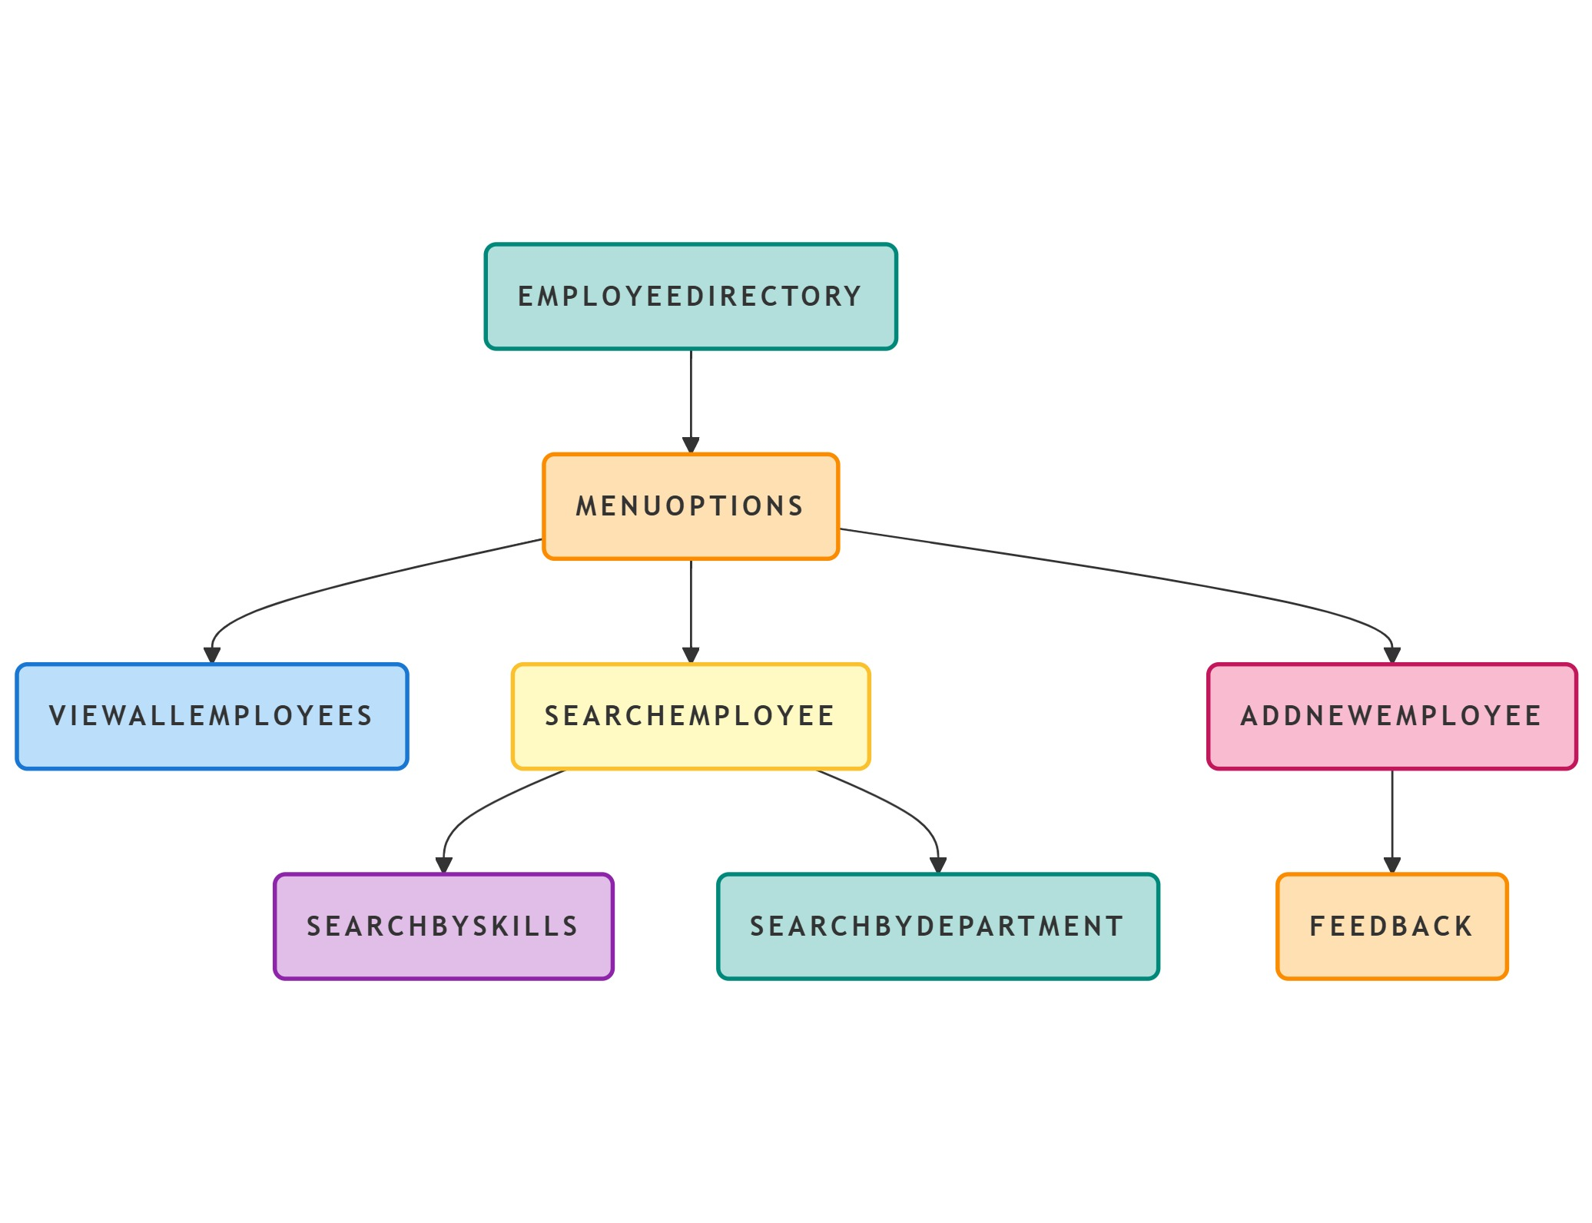

4.2 Output:
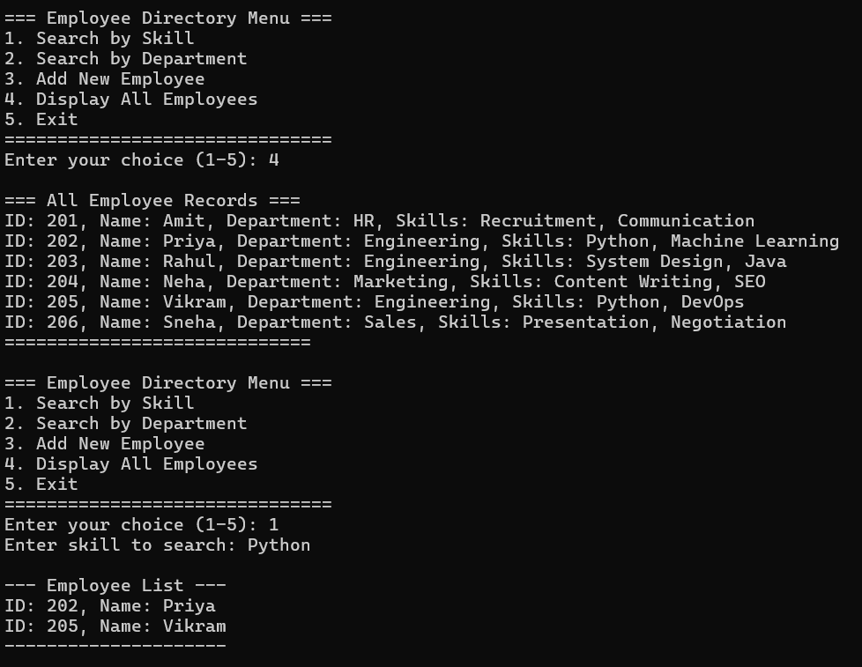
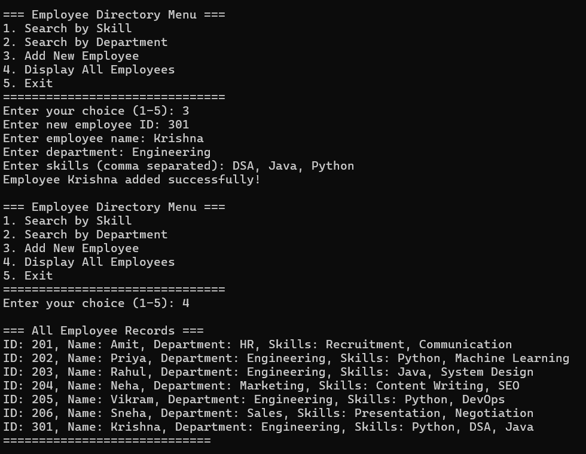

Chapter - 5
Results and Discussions

The Employee Directory with Department and Skill Sets system has been successfully implemented, offering a user-friendly interface and efficient backend functionality. After conducting multiple tests, the system demonstrates high accuracy in searching employees by their department, skills, and other attributes. The search functionality performs efficiently even with a large number of records, providing quick results in real time.
The ability to add new employees to the directory works seamlessly, with the system validating data entries and updating the database in real time. Administrators can easily input employee details such as names, roles, departments, and skills, ensuring the directory remains current and accurate.
However, a few challenges were encountered during the testing phase. For instance, handling large volumes of data may require performance optimizations in terms of indexing and query execution. Additionally, while the user interface is intuitive, some users suggested enhancements to the search filters for more precise results.
Overall, the system meets its primary objectives of simplifying employee management and enhancing the accessibility of employee data. Future improvements could include adding more advanced search filters, integrating the system with other internal tools, and optimizing performance for large-scale deployments.

Chapter – 6
Conclusion

The Employee Directory with Department and Skill Sets project successfully addresses the challenges of managing employee information in an organization. The system offers a streamlined, user-friendly platform that allows administrators and employees to easily search for and manage employee data based on criteria such as department and skills. It significantly reduces the time and effort spent on manual record-keeping and enhances the accessibility of essential employee information.
Through the development and implementation of this system, the objectives of simplifying employee management, improving searchability, and ensuring real-time updates to the directory have been achieved. The ability to add new employee records and perform efficient searches greatly benefits HR departments and managers, facilitating better decision-making and resource allocation.
While the system performs well, future enhancements could include further optimization for handling larger datasets, improved filtering options for more refined searches, and integration with other enterprise tools. The user interface could also be enhanced based on feedback for an even smoother experience.
In conclusion, the Employee Directory with Department and Skill Sets project provides an efficient, scalable solution for managing employee data, and with future improvements, it has the potential to serve as a core tool in organizational management.

References

[1] Sommerville, I. (2011). Software Engineering (9th ed.). Addison-Wesley.
[2] Pressman, R. S. (2014). Software Engineering: A Practitioner's Approach (8th ed.). McGraw-Hill.
[3] Kumar, S. (2022). Skill-Based Employee Directories for Agile Team Formations. Proceedings of the International Conference on Smart Workplaces, 215-221.
[4] OpenAI. (2025). Python-based Applications for HR and Employee Management. Retrieved from https://openai.com
[5] Smith, J. (2022). Effective Employee Management Systems: Best Practices for Directory Solutions. HR Tech Press.

